TEAM DEVELOPTERS



Documentation Format

* Problem Statement: A photo editing software using Python. We will call it Developters Photo-Kit.
* Requirements: Python installed on the system, an IDE, and a terminal to run the program.
* Technologies Used: Programming language used is Python, and its libraries.
* Project Description: This program has utilities to convert an image, provided by the user, to –
  + An ASCII-character .txt file
  + A Greyscale image
  + A Cartoonifyed image
  + A Sketch
* Scope (Features and Functions of the Project):
* The program run is password protected. Only authorised users will be able to convert the images.
* Multiple Python libraries, like PIL, Numpy, cv2 and tkinter, are used.
* A user can convert as many images as he/she wants to; the program asks if the user wants to continue or not.
* Easy to understand program.
* Challenges Faced:
* Following warning keeps coming up –

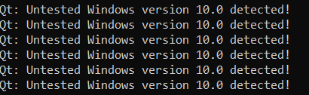

Qt: Untested Windows version 10.0 detected!

This doesn’t interfere with the program run if one is using command prompt, but in editors like VS Code, it freezes the program run.

* Integrating various libraries and their functions requires precision and knowledge.
* Conclusion: This is a fun and interesting program to make. It has two functionalities – makes for a good project and also provide us with a photo-editor.